1. DIRECT STRENGTH METHOD

The designation Direct Strength Method (DSM) was first mentioned in the pioneering work of Schafer and Peköz [1], in the context of developing new design approaches for CFS beams. The DSM should be understood as a procedure that can be adopted to develop methodologies for the design of a wide variety of thin-walled structural systems. This versatility/universality explains DSM’s quick acceptance by the technical/scientific community and the fast-growing number of successful applications of this design approach. The large amount of recent and ongoing research activity on DSM design applications will certainly be amply evidenced and reflected in upcoming versions of design codes concerning thin-walled structures [2].

* 1. The basic idea and its origin

Traditionally, the design of thin-walled steel members against local buckling has used the Effective Width Method (EWM), originally proposed by Von Kármán and later calibrated by Winter, which is incorporated in the current versions of nearly all worldwide codes addressing the design of such members. In the specific context of CFS structures, this method can be found, for example, in Eurocode 3 [3] ,(2) AISI (American Iron and Steel Institute) S100 *North American Specification for the* *Design of Cold-Formed Steel Structural Members* [4] and NBR14762 *Brazilian Standard on Design of Cold-formed Steel Structures*  [5].

The increase of cross-section’s shapes complexity and the unveiling of distortional buckling as a potential cause for the failure of CFS thin-walled members with lipped cross-sections paved the way for the development and popularity of the DSM [6]. Indeed, after a few fairly unsuccessful attempts to predict efficiently distortional failures by means of design methods based on an Effective Cross-Section (ECS) concept, it became clear that a more rational approach was needed. Ensuing research work led, after a decade or so, to the DSM, first codified in North America in 2004 [7], and almost simultaneously included in the Australian/New Zealand standard [8]. A few years later it was also adopted in Brazil [5]. The DSM provided a unified approach for the design of CFS members under compression (columns) and bending (beams) exhibiting L, D, G, and L-G interactive failures.

The DSM may approach as an extension of the use of column curves for global buckling, due to the fact that it is based on the assumption that a member’s ultimate strength can be accurately predicted solely on the basis of its elastic buckling and yield stresses ,i.e., , where is the member’s nominal strength, , , are the elastic local, distortional, and global buckling stresses, and is the steel yield stress. Figure 1provides the basic scheme concerning the application of the DSM. The elastic buckling and yield stresses are plugged into Winter-type equations that provide a estimate of the member’s ultimate strength instead of the effective cross-section, which is the cornerstone of the EWM, the DSM is based on accurate knowledge of the member’s buckling stress associated with the failure mode under consideration, which means that computational tools to evaluate it are indispensable.

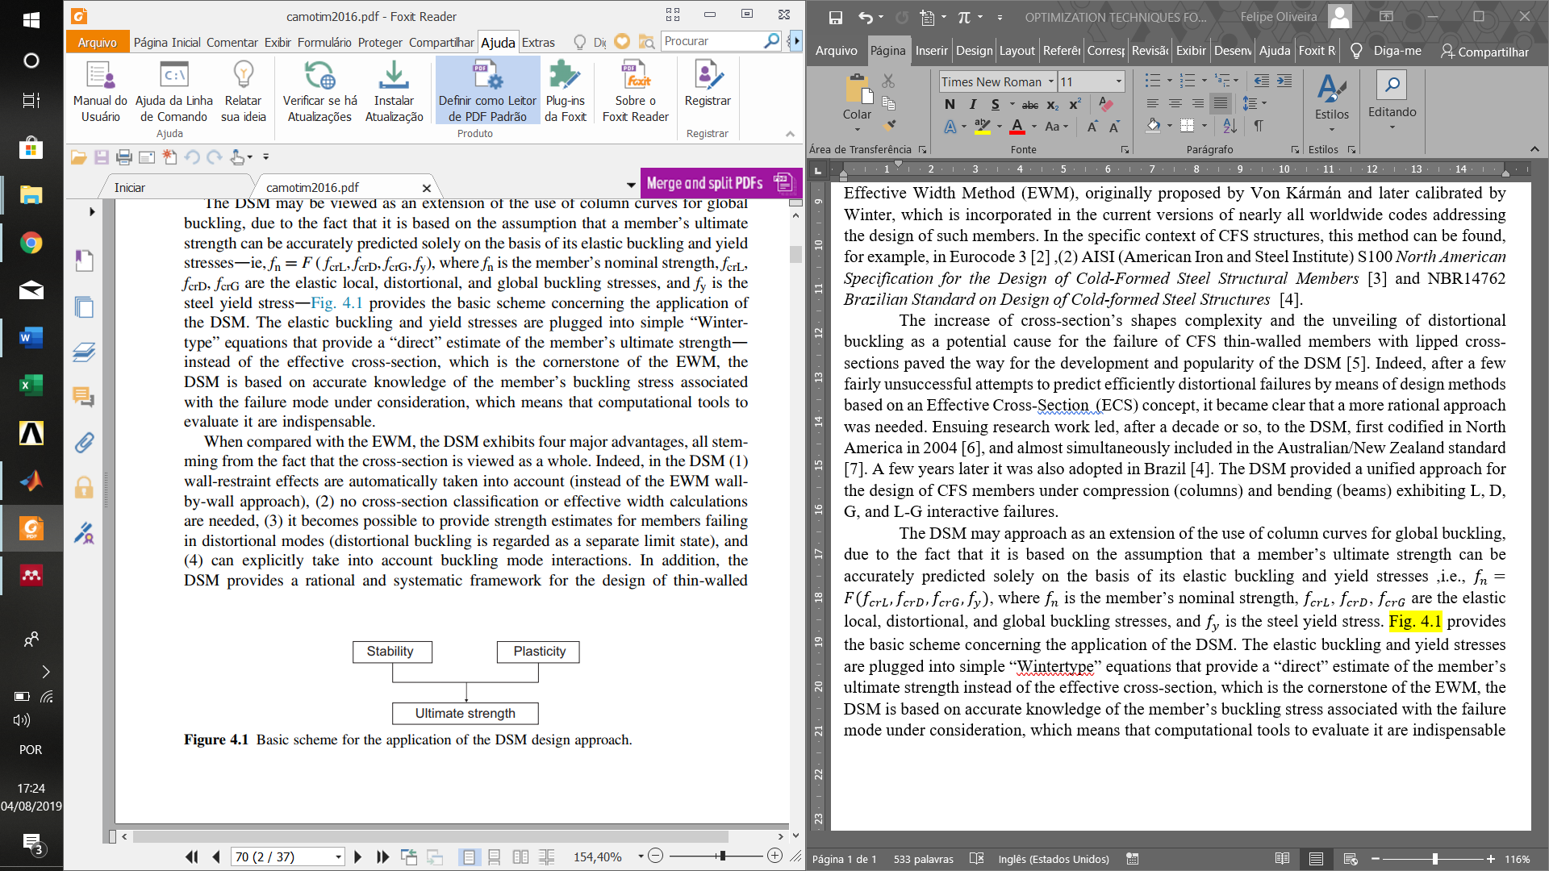

Figure 1: Basic scheme for the application of the DSM design approach

Comparing with the EWM, the DSM exhibits notorious advantages, all stemming from the fact that the cross-section is viewed as a whole. Indeed, in the DSM wall-restraint effects are automatically taken into account (instead of the EWM wall-by-wall approach), no cross-section classification or effective width calculations are needed, it is possible to provide strength estimates for members failing in distortional modes (distortional buckling is regarded as a separate limit state), and can explicitly take into account buckling mode interactions. In addition, the DSM provides a rational and systematic framework for the design of thin-walled structural systems made of various materials, the development of a given application needs proper calibration and validation through comparison with a fair number of experimental and/or numerical results [9].

* 1. DSM design curves

NBR 14672 [5] allows use of the DSM to determine the nominal axial () and flexural () strengths of any CFS columns and beams. However, this specification makes a distinction between “prequalified” and “non-prequalified” columns and beams, in the sense that different safety () and resistance () factors must be employed naturally, those applying to the prequalified members are less stringent.

For both columns and beams, the prequalified cross-section shapes include c-channel section, zed-section beams, lipped channels, hat and rack cross-sections. Figure 2 shows the prequalified column and beam cross-section shapes, indicating the wall angles and dimensions whose values or (mostly) ratios are covered by the prequalification. The members must satisfy the geometric criteria presented in Table 9 of NBR 14672 [5] which are those exhibited by the columns and beams considered in the development, calibration, and validation of the DSM design curves/expressions.

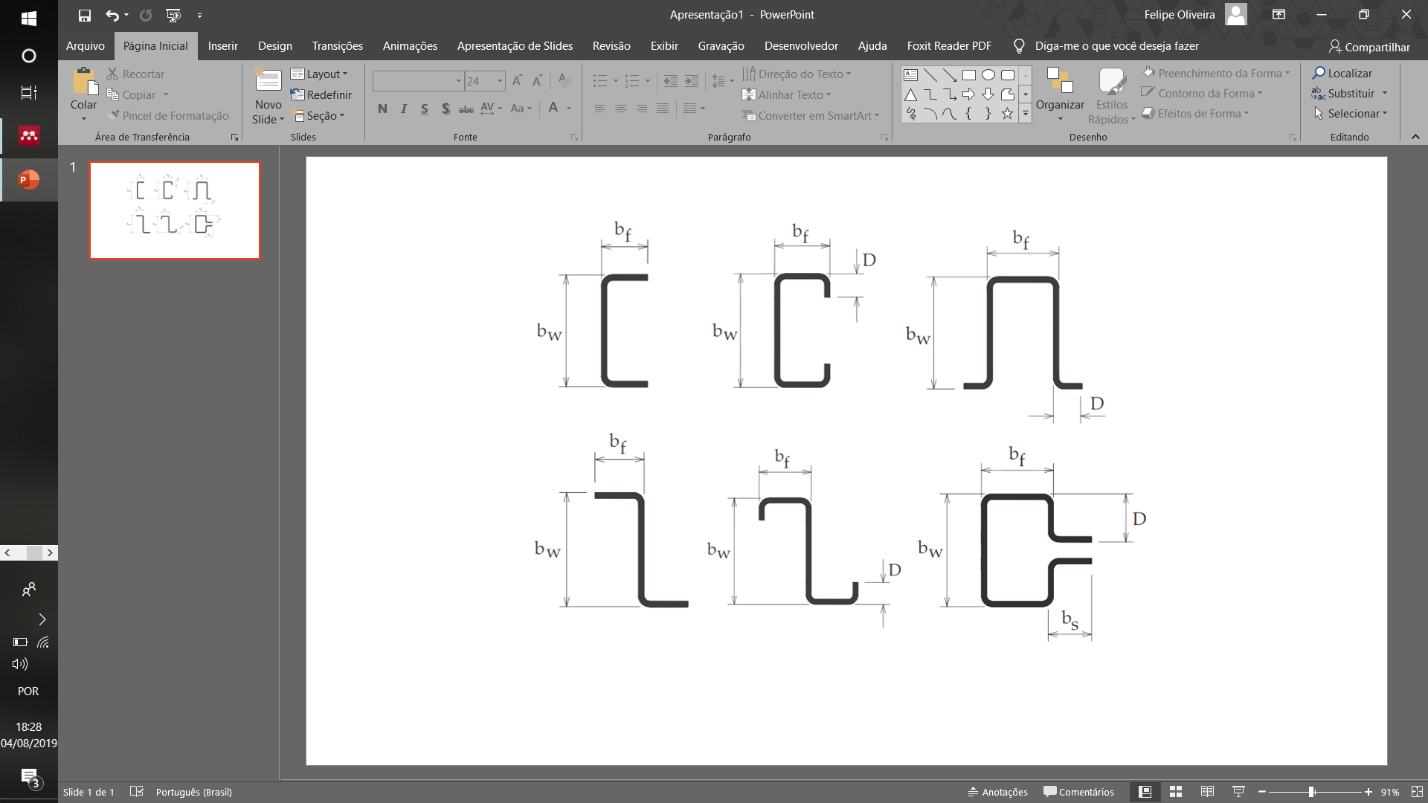

Figure 2: Prequalified cross-section shapes

The column and beam local, distortional, and global critical buckling loads/ moments can be calculated by shell finite element (SFE), constrained finite strip (cFS), or generalized beam theory (GBT) elastic linear buckling analyses. While the SFE analyses must generally be performed with commercial software packages , e.g. ANSYS [10] (which is the most commonly used), it is possible to carry out the others in freely available open source codes, namely CUFSM [11] and GBTUL [12] .Although SFE analyses are more versatile, in the sense that they can be applied to columns and beams with all types of support and loading conditions, the cFS or GBT analyses should be employed whenever possible. Indeed, due to their modal character, they make it much easier to identify the nature of the critical buckling modes (or calculate the critical buckling load associated with a specific buckling mode nature),the SFE analyses often entail the need to consider a large number of buckling modes to determine a given elastic buckling load/moment. In particular, it is worth mentioning that, as far as prismatic CFS members are concerned, the GBTUL capabilities match very closely those exhibited by SFE analysis [13].

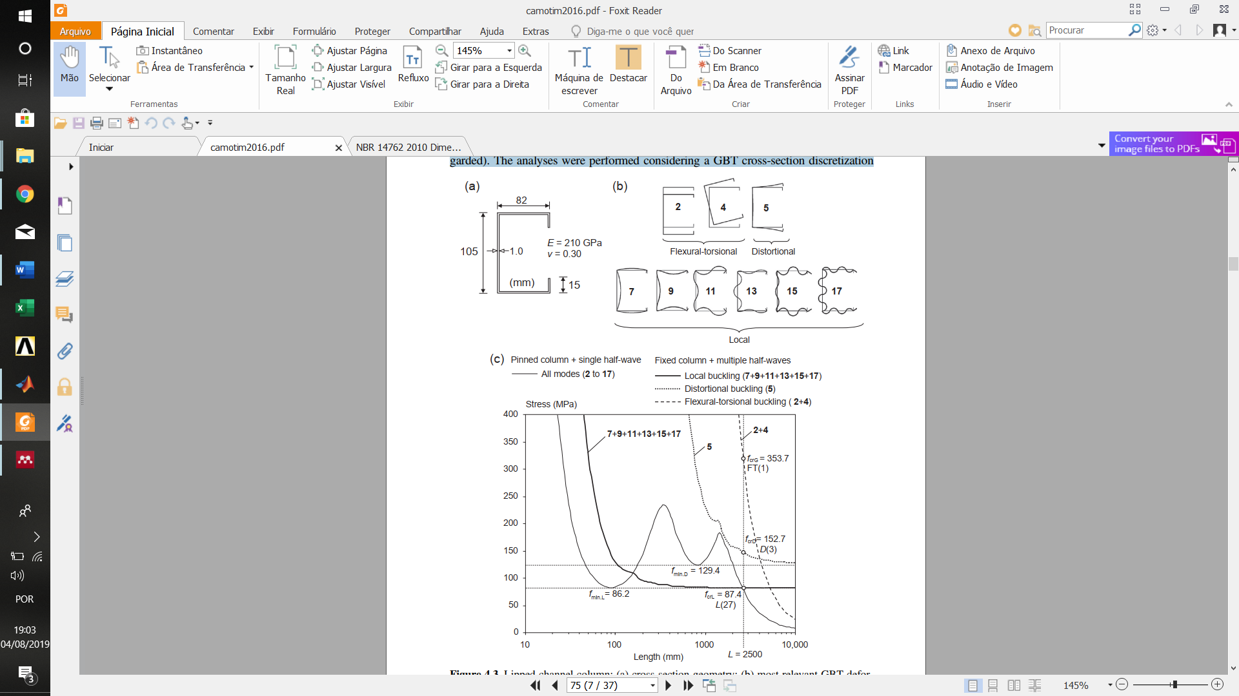

Figure 3: Lipped channel column: (a) cross-section geometry; (b) most relevant GBT deformation modes (used to calculate , , and (c) buckling curves , , (fixed- and pin-ended columns)

Figure 3 illustrates the evaluation, by means of GBT analyses, of the critical buckling stresses ) of the fixed-ended lipped channel column with the cross-section depicted. The analyses were performed considering a GBT cross-section discretization involving three intermediate nodes in the web and flanges, which leads to 17 deformations modes. Figure 3(b) displays the in-plane shapes of: all symmetric local modes (7, 9, 11, 13, 15, 17), the symmetric distortional mode 5, the global modes 2 and 4.The thin solid curve depicted in Figure 3 (c) is the signature curve, corresponding to simply supported columns buckling in single half-wave modes, it may be obtained from semi-analytical FS or GBT analyses. The remaining three curves, obtained from numerical GBT analyses, concern fixed-ended column buckling in multiple half-wave modes. The thick solid, dotted, and dashed curves provide, respectively, the variation of , , and (the three white circles in Figure 3 (c)), which are the values required to apply the DSM.

* + 1. Compressive strength

To develop the DSM, Schafer collected a fairly large data bank of experimental failure loads concerning CFS columns with various cross-section shapes (plain and web-stiffened lipped channels, hats, zeds, and racks) and failing in L, D, and G modes [9]. The DSM determines the nominal compressive strength given by a Winter-type curve, provided the user specifies the yield load ( and the elastic critical loads in global , local and distortional and buckling modes.

The nominal compressive strength in global buckling is given by:

where is the global buckling slenderness, given by:

Because the local failure of compressed members might occur in combination with global buckling, DSM prescribes the calculation of the nominal strength of columns failing in local-global modes. The nominal strength for local-global buckling failure is given by:

where is the local-global buckling slenderness, given by:

Note that the global strength must always be calculated prior to local-global buckling strength . According to Schafer, the L-G strength was always considered in these calculations because . The nominal strength for distortional buckling is given by:

where is the distortional buckling slenderness, given by:

Then, the column nominal axial strength is equal to . It is worth noting that, due to the different amounts of postcritical strength reserve associated with local, distortional, and global buckling, the natures of the critical buckling and failure modes are not necessarily the same, thus the need to evaluate , , and .

The merits and reliability of the DSM design approach for columns were also assessed by Schafer, as discussed and summarized in Schafer [9]. It was clearly shown that this design methodology provides good estimates for the whole set of 249 experimental failure loads, as attested by test-to-predicted-failure load ratio indicators: average and standard deviation equal to 0.98 and 0.14 and Load and Resistance Factor Design (LRFD) resistance factor equal to .

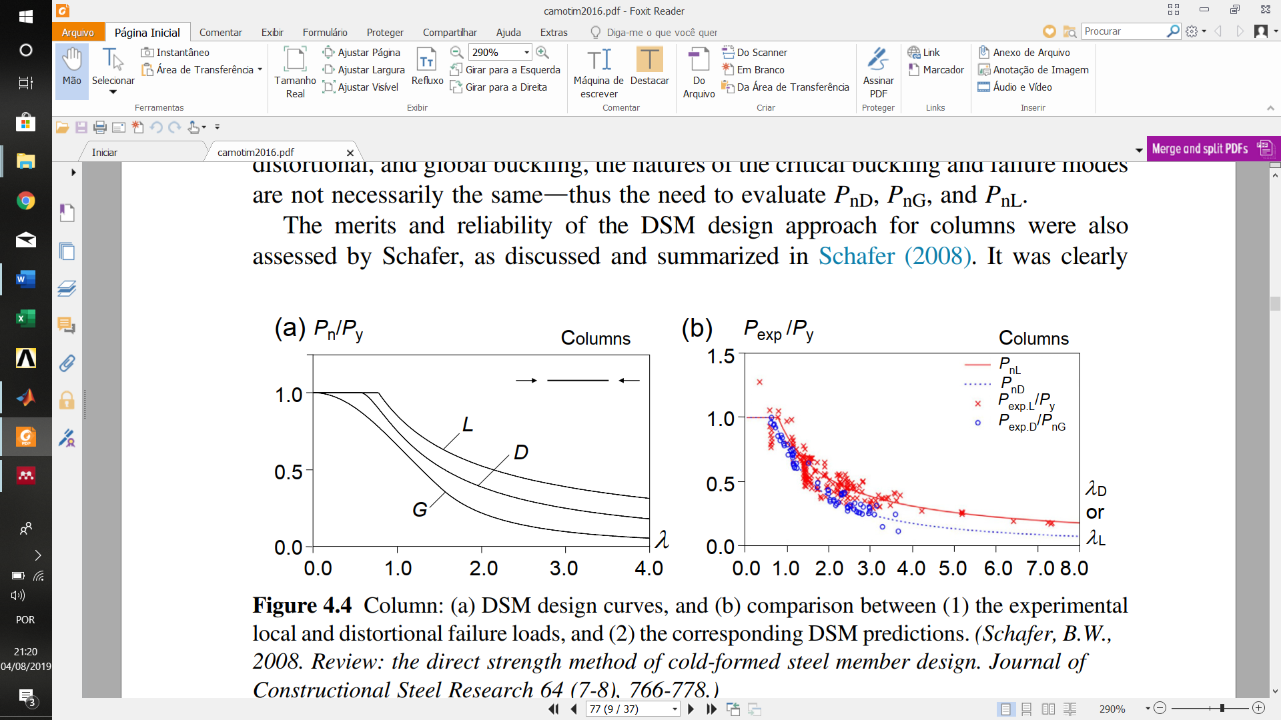

Figure 4: Column: (a) DSM design curves, and (b) comparison between (1) the experimental local and distortional failure loads, and (2) the corresponding DSM predictions [9].

Figure 4,adapted from AISI and Schafer [4], [9], provides an overall comparison between the experimental failure loads used to develop the DSM local and distortional design curves, and the corresponding DSM predictions.

* + 1. Bending strength

As pointed out earlier, Schafer and Peköz [1] ,in the context of the design of beams. The authors addressed two problems, namely the distortional failure of beams with lipped channel and zed cross-sections, and the L-D failure of beams with deck sections exhibiting multiple intermediate stiffeners in the compression flange .Summarizing their proposal, DSM determines the nominal flexural strength of CFS beams, provided the user specifies yield moment ( and the elastic critical loads in local , distortional and global buckling modes. Then, similarly to the columns, the beam nominal bending strength is equal to .

The nominal strength in the lateral torsional buckling is given by:

where is the global buckling slenderness, given by:

Because the local failure of flexed members might occur in combination with lateral torsional buckling, DSM prescribes the calculation of the nominal strength of beams failing in local-global modes. The nominal strength for local-global buckling failure is given by:

where is the local-global buckling slenderness, given by:

The nominal strength for distortional buckling is given by:

where is the distortional buckling slenderness, given by:

As for columns, the merits and reliability of the DSM design approach for beams were assessed by Schafer, and the output can be found in Schafer [9]. The design methodology provides good estimates for the whole set of 559 experimental failure: average and standard deviation equal to 1.09 and 0.12, respectively, and LRFD resistance factor equal to .

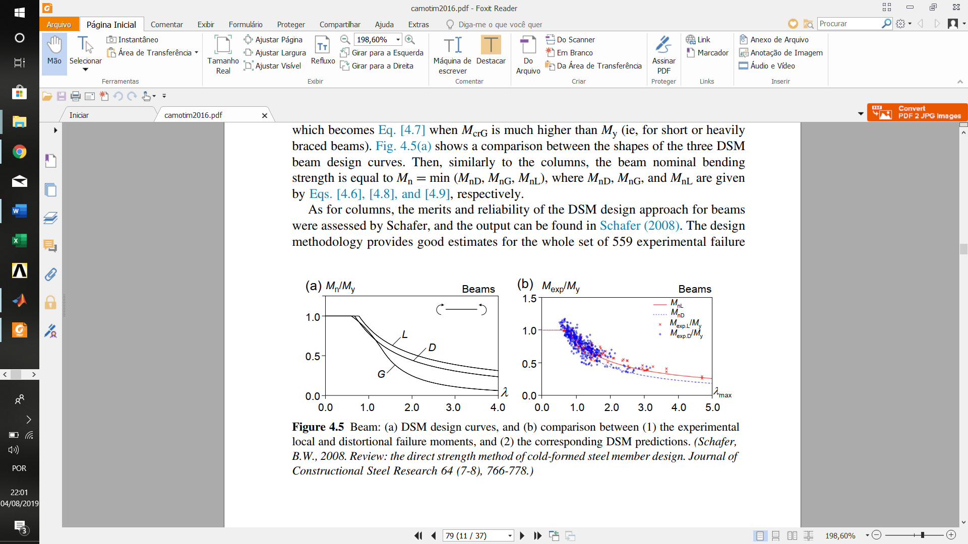

Figure 5: Beam: (a) DSM design curves, and (b) comparison between (1) the experimental local and distortional failure moments, and (2) the corresponding DSM predictions [14].

Figure 5 (b), adapted from AISI (2012) and Schafer (2008), provides an overall comparison between the experimental failure moments used to develop the DSM local and distortional design curves, and the corresponding DSM predictions.

There are a few aspects concerning the codified beam DSM design curves that are worth mentioning:

1. Although most of the experimental results considered in the development of the beam DSM design curves involved lipped channel and zed-section beams subjected to major-axis bending, it was assumed that these curves remain valid for beams under minor-axis bending, which can only exhibit L or D failures.This assumption is partially backed by the quality of the DSM predictions of experimental failure moments of hat section and deck section beams bent about the minor axis
2. Since the DSM design curves were basically developed for beams under uniform bending), they provide lower bound estimates for beams acted by nonuniform bending moment diagrams. To obtain more accurate predictions, it is indispensable to take into account the bending moment diagram shape. Although this issue has satisfactorily solved for lateral-torsional failures long ago,it has not been adequately tackled for distortional and L-G interactive failures.
3. A numerical investigation on lipped channel beams under major-axis bending [15] that the current DSM distortional design curve often provides unsafe failure moment predictions in the high slenderness ranged the amount of overestimation depends on the beam cross-section geometry and end support conditions, particularly those concerning the warping restraint. Figure 5 (b) shows that the vast majority of the failure moment data employed to develop Eq. [4.6] is associated with and, within this slenderness range, these expressions yield good-quality estimates.
   1. Interactive failures involving distortional buckling

The currently codified column and beam DSM design curves cover only local, distortional, global, and L-G interactive failures, there is ongoing research work on the understanding and prediction of the ultimate strength erosion caused by the remaining interaction phenomena, namely those involving distortional buckling: local-distortional (L-D), distortional-global (D-G), and local-distortional-global (L-D-G) interaction. It is fair to say that the vast majority of this research has been devoted to columns, although investigation on beams has been initiated, eg, Martins et al.[16], Martins et al. [17] and Nandini and Kalyanaraman [18], on L-D,D-G and L-D-G interaction, respectively. Concerning L-D interaction, by far the most studied among the above three coupling phenomena and for which there exists clear experimental evidence of ultimate strength erosion, eg, Kwon and Hancock [19] and Kwon et al. [20] . Martins et al.[16] , clearly identifying and investigating two sources for L-D interaction coupling phenomenon, namely the closeness between the local and distortional critical buckling loads ,causing true interaction, and, in the absence of such closeness, the high noncritical slenderness, causing secondary bifurcation interaction, which is particularly relevant when local buckling is critical). Also showed that true L-D interaction effects may cause a relevant failure load erosion when .

On the basis of a numerical and experimental investigation involving lipped channel columns with broad local ratio (, Matsubara et al.[21] ,showed accurate failure load estimates for , but very restrictive in geometry aspect. It provides two ultimate strength surfaces estimates ( given by a Winter-type curve.

The experimental coefficients ,A and B, of first strength surface suggested by Matsubara et al.[21] are given by:

The experimental coefficients ,A and B, of second strength surface suggested by Matsubara et al.[21] are given by:

Figure 6 shows the examples of numerical Shell Finite Element Models (SFEM) columns and ultimate strength of Finite Element Models (PuFEM) variation related to slenderness factor of lipped channel CFS columns ,proposed by Matsubara et al.[21]

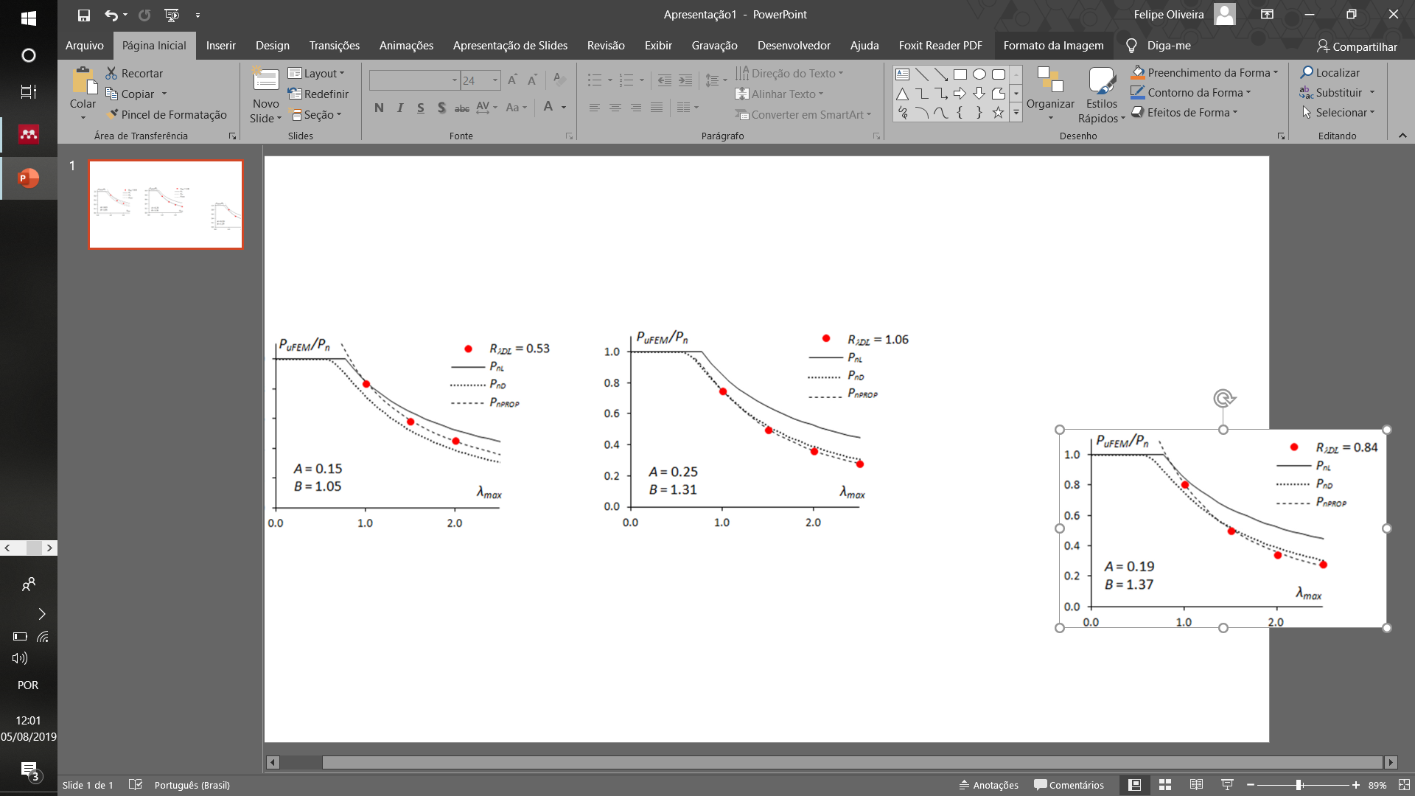

Figure 6:Results of Matsubara proposition

The D-G interaction is phenome with less scientific reports between the interactive failures involving distortional buckling, worth to cite the recently research of Martins et al.[17], [22] and Chong et al.[23] . Some of research work which has been done to investigate the L-D-G interaction in plain lipped channel columns namely test campaigns carried out in COPPE’s Thin Walled research group [24], [25] and Young et al [26].The latter, in particular, provided very clear experimental evidence of ultimate strength erosion caused by the simultaneous occurrence of local, distortional, and global deformations. On the basis of the experimental failure loads obtained, as well as the numerical results of limited parametric studies, it appears that the currently codified DSM design curve associated with L-G interactive failures provides efficient estimates of the columns undergoing the triple interaction under. Although this conclusion is preliminary and needs further experimental and numerical confirmation, by considering columns with other cross-section shapes, it appears that no new DSM design curve is necessary to handle column L-D-G interactive failures.

References

[1] B. W. Schafer e T. Peköz, “Direct strength prediction of cold-formed steel members using numerical elastic buckling solutions”, 1998.

[2] D. Camotim, P. B. Dinis, e A. D. Martins, *Direct strength method-a general approach for the design of cold-formed steel structures*, vol. 3, no 1. Elsevier Ltd, 2016.

[3] H. Herrmann e H. Bucksch, “Eurocode 3 - Design of steel structures”, in *Dictionary Geotechnical Engineering/Wörterbuch GeoTechnik*, 2014.

[4] AISI, “S100-07/S2-10, North American Specification for the Design of Cold-Formed Steel Structural Members, Supplement No.2”, *American Iron and Steel Institute*, Washington, DC, 2010.

[5] ABNT, “NBR 14762 -Dimensionamento de estruturas de aço constituídas por perfis formados a frio”, *Associação Brasileira de Normas Técnicas*, Rio de Janeiro,RJ, p. 237, 2010.

[6] B. W. Schafer, A. Sarawit, e T. Peköz, “Complex Edge Stiffeners for Thin-Walled Members”, *J. Struct. Eng.*, 2006.

[7] AISI, “North American Specification (NAS) for the Design of Cold-formed Steel Structural Members”, *American Iron and Steel Institute*, Washington, DC., 2004.

[8] AS/NZS, “Cold-formed Steel Structures. AS/NZS 4600”, *Standards of Australia and Standards of New Zealand*, Sydney-Wellington, 2005.

[9] B. W. Schafer, “Review: The Direct Strength Method of cold-formed steel member design”, *J. Constr. Steel Res.*, vol. 64, no 7–8, p. 766–778, 2008.

[10] ANSYS, “ANSYS Mechanical APDL Theory Reference”, *ANSYS Inc*, 2013.

[11] B. W. Schafer, “CUFSM”. Johns Hopkins University, 2012.

[12] D. Bebiano, R., Dinis, P.B., Silvestre, N., Camotim, “GBTUL e Buckling and Vibration of Thin-walled Members”. University of Lisbon, 2014.

[13] R. Bebiano, D. Camotim, e R. Gonçalves, “GBTUL 2.0 − A second-generation code for the GBT-based buckling and vibration analysis of thin-walled members”, *Thin-Walled Struct.*, 2018.

[14] Z. Li, “Buckling Analysis of the Finite Strip Method and Theoretical Extension of the Constrained Finite Strip Method for General Boundary Conditions.”, Research Report, Baltimore, MD, 2009.

[15] A. Landesmann e D. Camotim, “Distortional failure and DSM design of cold-formed steel lipped channel beams under elevated temperatures”, *Thin-Walled Struct.*, 2016.

[16] A. D. Martins, P. B. Dinis, D. Camotim, e P. Providência, “On the relevance of local-distortional interaction effects in the behaviour and design of cold-formed steel columns”, *Comput. Struct.*, vol. 160, p. 57–89, 2015.

[17] A. D. Martins, D. Camotim, e P. B. Dinis, “On the distortional-global interaction in cold-formed steel columns: Relevance, post-buckling behaviour, strength and DSM design”, *J. Constr. Steel Res.*, vol. 145, p. 449–470, 2018.

[18] P. Nandini e V. Kalyanaraman, “Strength of cold-formed lipped channel beams under interaction of local, distortional and lateral torsional buckling”, *Thin-Walled Struct.*, vol. 48, no 10–11, p. 872–877, 2010.

[19] B. Y. B. Kwon e G. J. Hancock, “Tests o f cold - formed channels with local and dlstortional buckling”, vol. 117, no 7, p. 1786–1803, 2006.

[20] Y. B. Kwon, B. S. Kim, e G. J. Hancock, “Compression tests of high strength cold-formed steel channels with buckling interaction”, *J. Constr. Steel Res.*, vol. 65, no 2, p. 278–289, 2009.

[21] G. Y. Matsubara, E. de M. Batista, e G. C. Salles, “Lipped channel cold-formed steel columns under local-distortional buckling mode interaction”, *Thin-Walled Struct.*, vol. 137, no July 2018, p. 251–270, 2019.

[22] A. D. Martins, D. Camotim, e P. B. Dinis, “Distortional-global interaction in lipped channel and zed-section beams: Strength, relevance and DSM design”, *Thin-Walled Struct.*, vol. 129, no February, p. 289–308, 2018.

[23] C. Ren, B. Wang, e X. Zhao, “Numerical predictions of distortional-global buckling interaction of perforated rack uprights in compression”, *Thin-Walled Struct.*, vol. 136, no November 2018, p. 292–301, 2019.

[24] P. B. Dinis, E. M. Batista, D. Camotim, e E. S. Dos Santos, “Local-distortional-global interaction in lipped channel columns: Experimental results, numerical simulations and design considerations”, in *Thin-Walled Structures*, 2012.

[25] E. Souza dos Santos, E. de Miranda Batista, e D. Camotim, “Cold-formed steel columns under L-D-G interaction”, *Steel Constr.*, vol. 7, no 3, p. 193–198, 2014.

[26] B. Young, P. B. Dinis, e D. Camotim, “CFS lipped channel columns affected by L-D-G interaction. Part I: Experimental investigation”, *Comput. Struct.*, vol. 207, p. 219–232, 2018.